Building Permit Edition
Wall Program

Instruction Guide



Table of Contents

SECTION 1: Introduction On How To Use Windloadcalc.com Software 3
SECTION 2: Building Information 5
SECTION 3: Topographic Factor 14
SECTION 4: Automatically Calculated Wall Information 16
SECTION 8: Opening Wind Load Design Information 16
SECTION 9: Print Layout For Opening Wind Load Design Information 18

SECTION 1: Introduction On How To Use Windloadcalc.com Software

Note 1: All information is according to the ASCE 7 (American Society of Civil Engineers) and IBC (International Building Code)

Note 2: Descriptions are provided (according to ASCE 7) to give you information that must be entered to calculate wind loads. You simply run your cursor over the cell over the description title (shown in description below). This is typical throughout the wind load analysis process.

Note 3: The required information are feed into the ASCE 7 program. The values are place in the ASCE 7 formulas and all information is interpolated within the whole process of/ for calculations; giving you the most precise calculation. The only values that are rounded-off for an answer is the final value; which is your wind load pressure value. The Maximum Uplift or Windward (Positive) Pressure and the Maximum Down Force or Leeward (Negative) Pressure is rounded to the nearest tenth. Those pressure values are converted to the load values, which are rounded to the nearest whole number.

Note 4: There are little red markers on the cell for the required information. That means if you run your cursor over the cell then it will give you a description of what it’s about, to help you how to figure out what needs to be entered into each

- Building Information: This is the information about your building.

  - Required Information about you building:
  - Wind Velocity (mph)
  - Building Category
  - Importance Factor
  - Exposure
  - Internal Pressure
  - Mean Roof Pressure (ft)
  - Building Width (ft)
  - Building Length (ft)
  - Roof Slope (x:12)
  - Edge Strip (ft)
  - End Zone (ft)

We will go through each itemized piece of information that is required for calculating wind loads, starting with how to properly enter your values for ‘Building Information’.
- Wind Velocity: This is the Basic Wind speed that your building will be built in. You can find this on the Basic Wind Speed Maps shown provided in the ASCE 7.
        - Value is the nominal design 3-second gust wind speed in miles per hour at 33 ft above the ground.
- Building Category: You can select the correct Building Category from the pull-down list in the pull-down menu. You are given the Building Categories available from ASCE 7, such as Hurricane Category 1-4, or Non-Hurricane Category 1-4. You can also reference the Building Categories in ASCE 7 on Table 1-1.
- Importance Factor: This factor accounts for the degree of hazard to human lift and damage to property.
  - This value is determined by the selection of your ‘Building Category’. Once selected the Importance Factor is automatically calculated. Dependant upon you selection, the value for ‘Low Hazard to Human Life’, ‘Typical Buildings’, ‘High Hazard to Human Life’, or ‘Essential Facilities’ will be given.
- Exposure: This value is calculated into the program based upon the Exposure Category selected. Exposure Categories are: B, C, D. Exposure A (as of ASCE 7-02) is no longer a selection. You can find the descriptions in the ASCE 7 book under “Exposure Categories”.
- Internal Pressure: This value is determined based upon your selection of your building’s Enclosure Classification. The correct GCpi value is calculated into the program dependant upon if you choose ‘Open Building’, ‘Partially Enclosed’ Building, or ‘Enclosed’ Building.
- Mean Roof Height: This is the average of the roof eave height and the height to the highest poiont on the roof surface, except that, for the roof angles of less than or equal to 10 degrees, the mean roof height shall be the roof eave height. (Reference: ASCE 7).
- Building Width: This is the distance in ‘feet’ of the width of the building need wind load calculations for.
- Building Length: This is the distance in ‘feet’ of the length of the building you need wind load calculations for.
- Roof Slope: This is displayed as: (x:12), meaning the value of ‘x’ is needed to determine the slope of your roof. The value of ‘x’ is divided by 12. This is a typical way to display the slope on drawings. This has a tragicomic function (Ө = arctan((x/12)*(180/pi)).
- (a) Edge Strip: This is the width of 10% of the least horizontal dimension or 40% of the height. Whichever the case, (a) shall not be less than either 4% of the least horizontal dimension or 3 ft
        - This wind load requirement is automatically calculated by Windloadcalc.com.
- End Zone: This value is the two times the width of the edge strip (a). This wind load calculation is also automatically calculated by Windloadcalc.com

SECTION 2: Building Information

This is the section that you fill-in first. The program requires specific building information that is custom to each building that you require wind pressures for. Let’s get started.
Go to this part of the program:
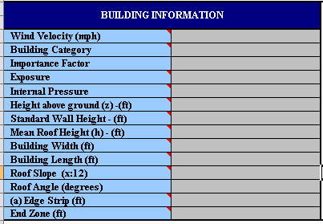
You will work you way down from the top to the bottom.
- Wind Velocity
  - First go to ‘Wind Velocity’. This value will be entered in MPH, and can be read from the maps from you ASCE 7 book. Below are the Velocity Zone maps that you should reference.
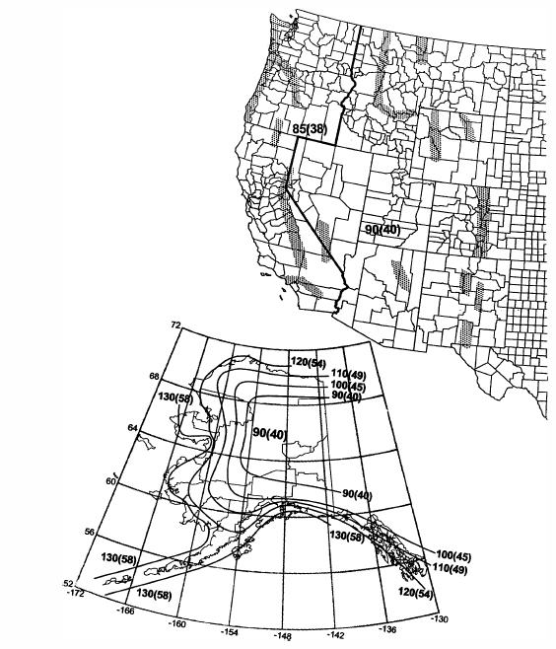
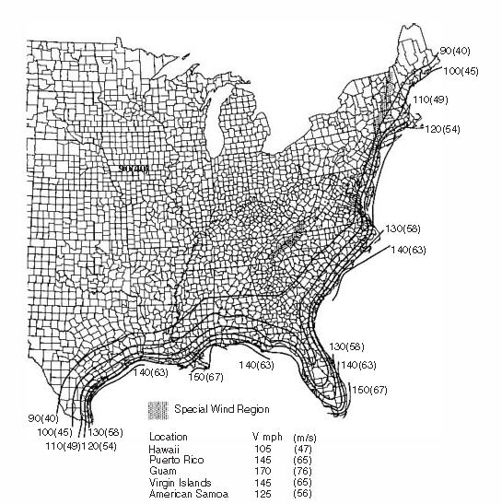

    - Once you have located what Velocity Zone your building is in, enter that value like we show below.
    - Our building is in Miami, Florida, so it is in the 146 mph zone.
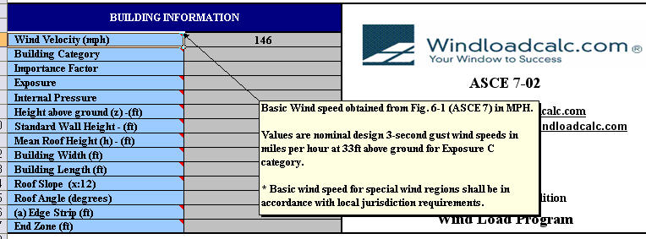

- Building Category
  - Next we will enter our ‘Building Category’. We will put our cursor over the ‘Building Category’ cell to see the description, and then we can select which category is represents the building the best; from the pull-down list.
    - We are selecting Building Category 2 in the Hurricane Region.
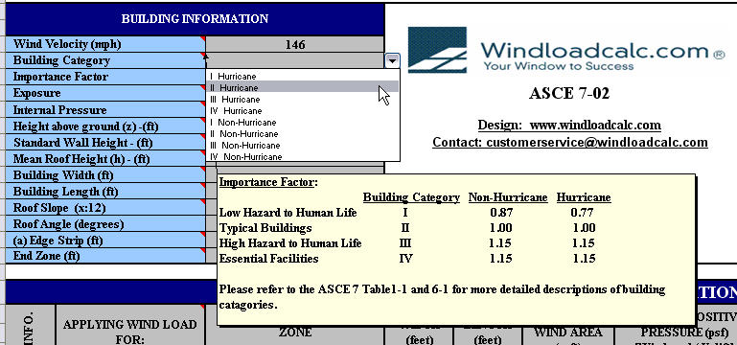
- Importance Factor
  - This value is selected and automatically placed in the calculation, based from the ‘Building Category’ that is selected. This factor accounts for the degree of hazard to human life and damage design winds*.
  - Our ‘Importance Factor’ is 1.0.
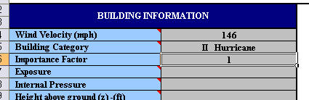

- Exposure
  - Again, we will put our cursor on the ‘Exposure’ cell to read the description, and then we’ll select from the pull-down list.
  - Miami, Florida requires a ‘C – Exposure’
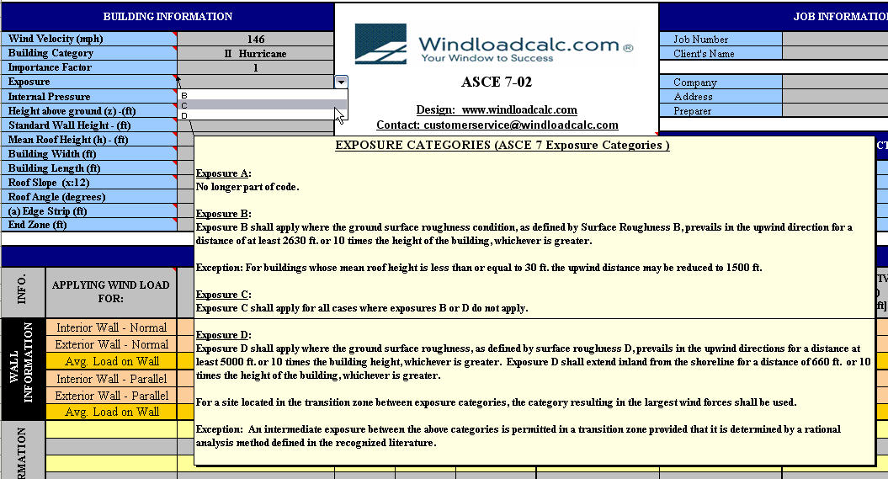
- Internal Pressure
  - Here we will chose the ‘Internal Pressure’, which is determined from the type of structure you’re building.
  - Our building is a residential home, so we are choosing ‘Enclosed’.
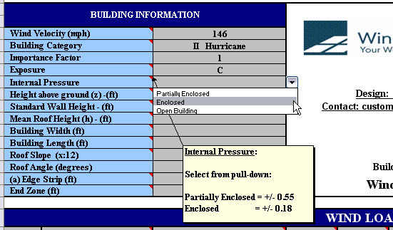

- Height Above Ground
  - Here you enter in the dimension, if you building is elevated. You would enter the dimension measured from grade to the bottom of your building.
  - Our building is not elevated, so the value zero is entered.
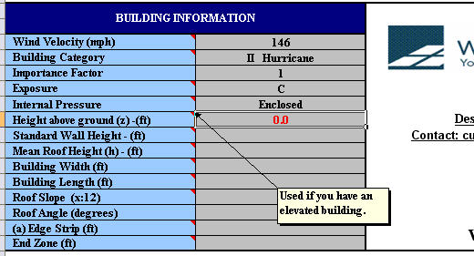
- Standard Wall Height
  - Now you want to enter in the ‘Standard Wall Height’ for your calculation. This is the eave height which is the distance from the bottom of the main frame column base plate to the top outer point of the eave strut*.
  - For our calculation, our building has a ‘Standard Wall Height’ of 18 feet.
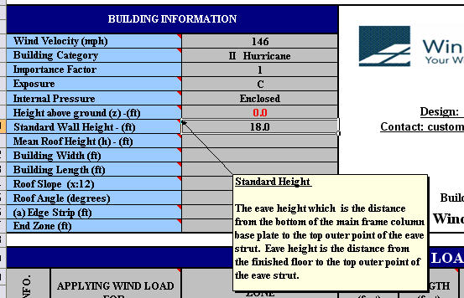

- Mean Roof Height
  - Next we will enter the ‘Mean Roof Height’. This is the average of the roof eave height and the height to the highest point on the roof surface*. The program calculates for all heights, even above 60 feet.
  - The ‘Mean Roof Height’ of our building is 30 feet.
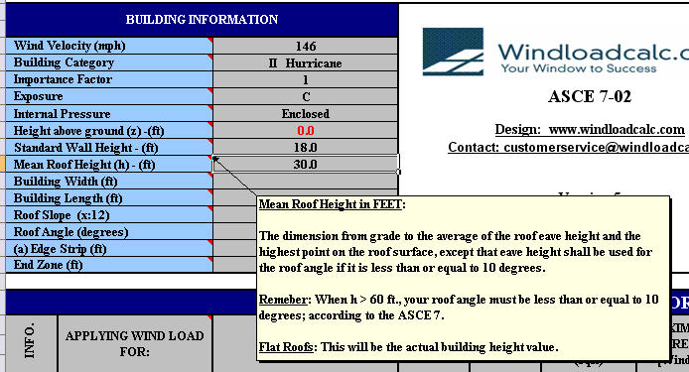
- Building Width
  - This is where you want to enter your building’s width dimension.
  - Our home’s dimension has a width of 180 feet.
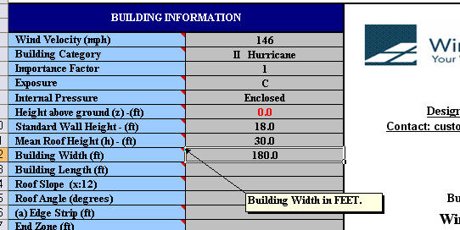

- Building Length
  - This is where you want to enter your building’s legth dimension.
  - Our home’s dimension has a length of 120 feet.
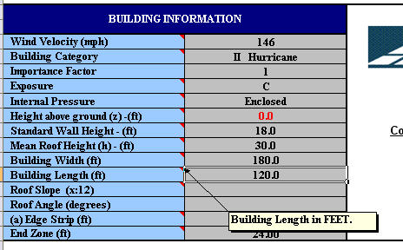

- Roof Slope & Angle
  - Now you enter the ‘Roof Slope’. This is the value that determines the angle of your roof. The roof angle is automatically calculated for you, based upon the slope value entered in.
  - We have a Slope of 9 (9/12), which gives us a value of 36.87 degrees.
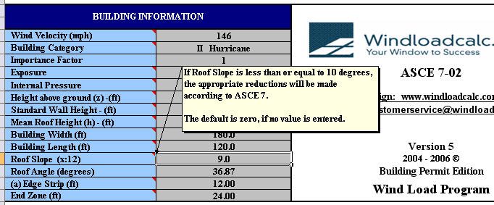

- Edge Strip & End Zone
  - The values of the ‘Edge Strip’ & ‘ End Zone’ are automatically calculated for you, based upon the information we have already entered into the program.
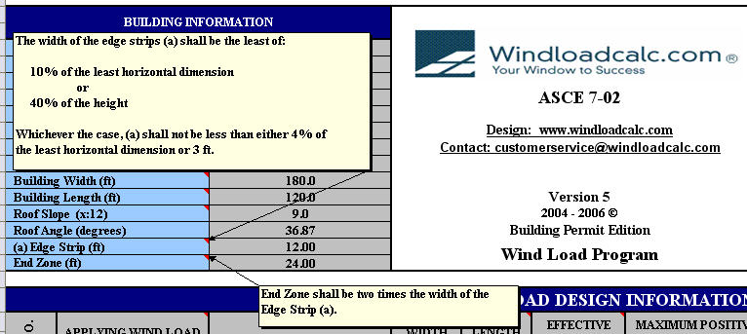

SECTION 3: Topographic Factor
This factor (according to ASCE 7) calculates the effects of the wind speed-up effects at isolated hills, ridges, and escarpments constituting abrupt changes in the general topography, located in any exposure category, and shall be included in the design when buildings and other site conditions and locations meet the conditions according to ASCE 7*.
- On the program the section looks like this:
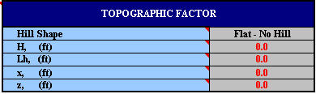

- Now we will select the ‘Hill Shape’ of the Topographic.
- Since we don’t have any escarpments around our building, we have selected ‘Flat – No Hill’.Look at the picture.
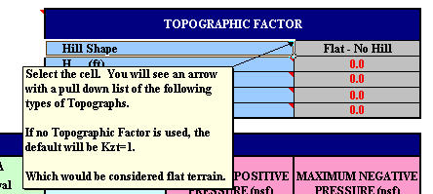

- Then from that I choose what I select what I need for my wind load calculation:
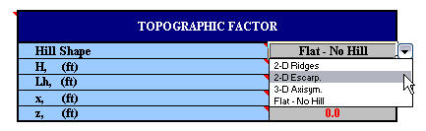

- The ‘Topographic Factor’ covers the following:
  - Height (H): Height of hill or escarpment
  - Distance Upwind (Lh): Distance upwind of crest of hill or escarpment where the difference in ground elevation is half the height of hill or escarpment.
  - Distance Upwind (x): Distance upwind or downwind of crest.
  - Height (z): Height above ground level.

- Compare with the diagram below.
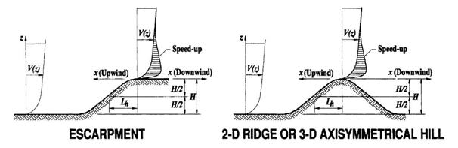

SECTION 4: Automatically Calculated Wall Information

From the information that we entered in the ‘Building Information’ automatically calculated the wind pressures and the wind loads for your building.
Below is what you will reference for your wall wind pressures and wind load calculations.
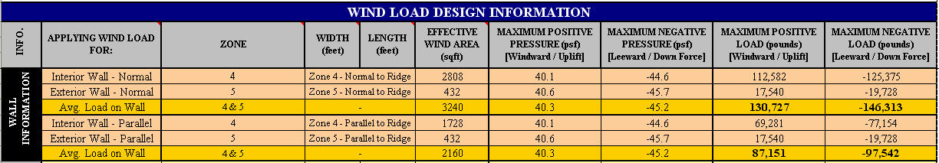

SECTION 8: Opening Wind Load Design Information
Now we are ready to find wind load pressures for specific openings (windows & doors) according to the ASCE 7 wind load analysis. The area labeled ‘Wall Opening Information’ (in the ‘INFO.’ column will be entered next on the wind load program.
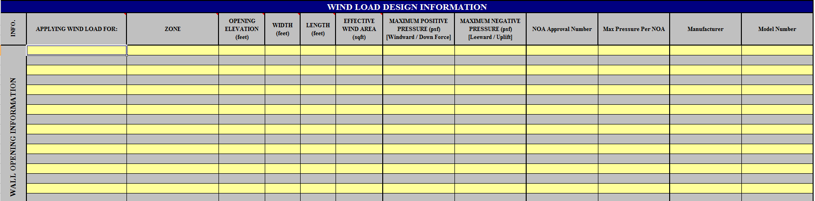

- First we will enter the type of opening we need to do a wind load calculation.
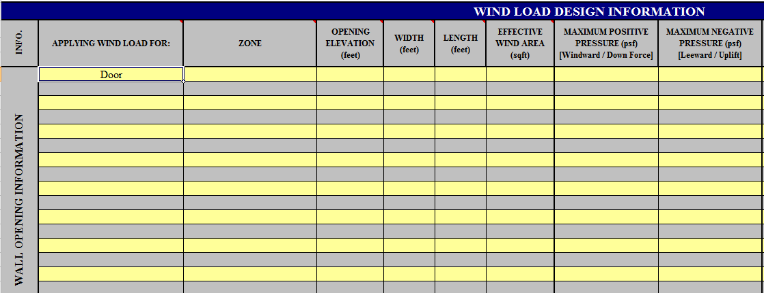

- Second we will select the zone for the opening.
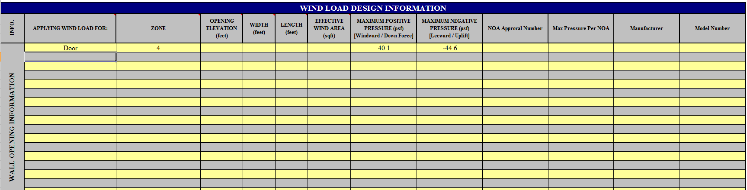

- Third we will put in the dimensions of our opening and its elevation. The Opening Elevation is the dimension from the ground to the center of your opening, and the Width and Length are the dimensions of your Opening. Given this information the program will calculate the most precise answers for your opening’s Windward and Leeward Pressures.
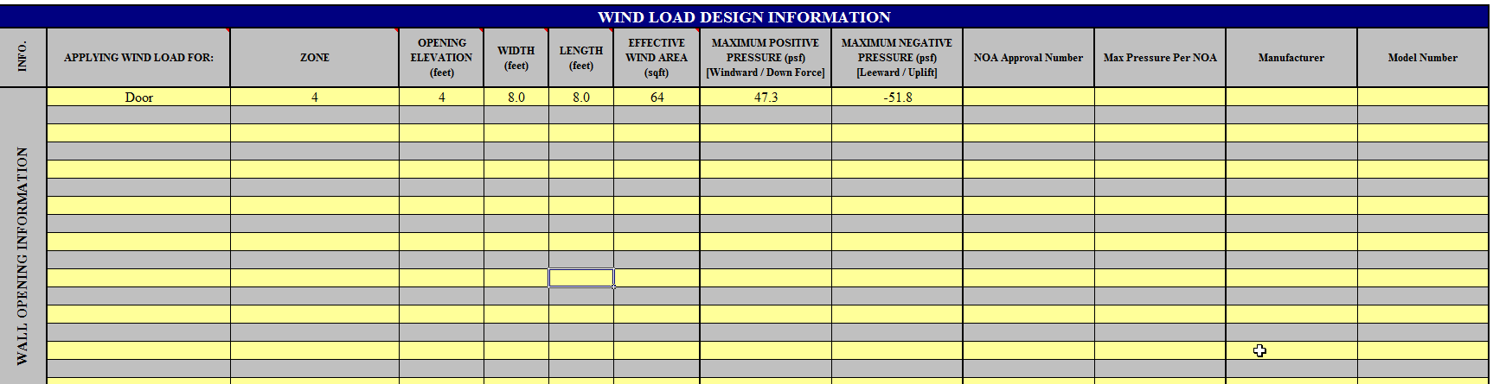

- Below are more openings that have been entered into the program.
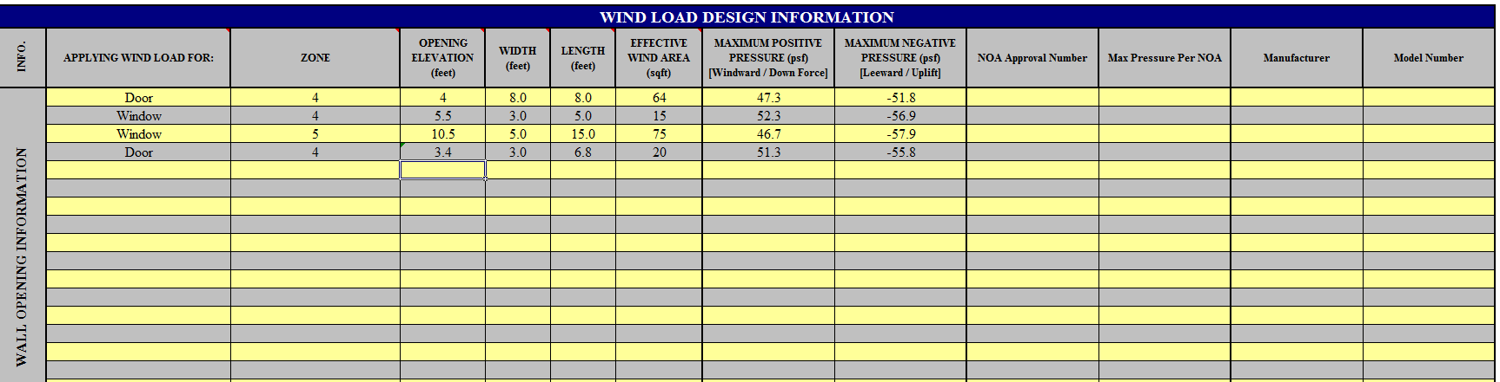

SECTION 9: Print Layout For Opening Wind Load Design Information

- Below is the wind load information formatted with the appropriate diagrams. (This is from the ‘Window & Door Output’ tab).

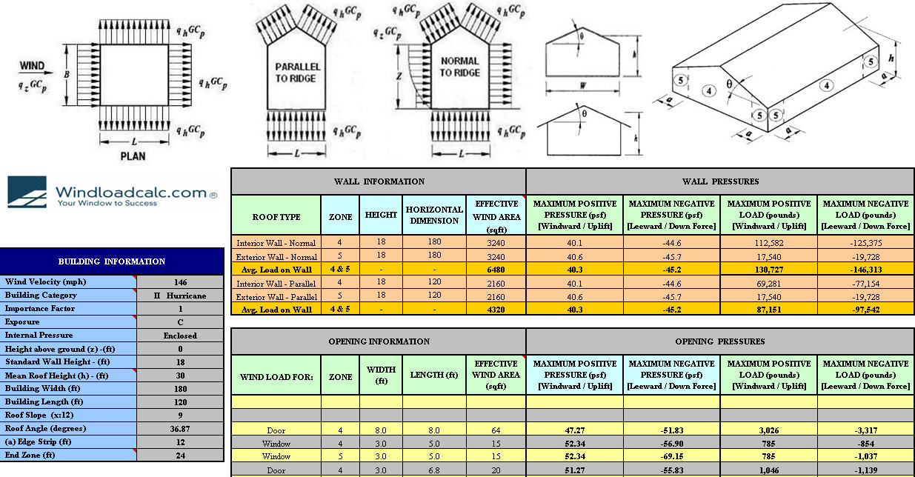

Finished!

